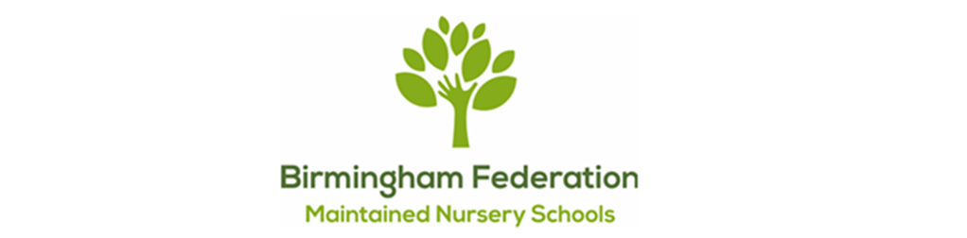

Adderley Nursery School | Allens Croft Nursery School | Gracelands Nursery School
Highfield Nursery School | Jakeman Nursery School | Lillian de Lissa Nursery School
Newtown Nursery School | Shenley Fields Nursery School | St Thomas Centre Nursery School

Sunshine (0-2’S)
Admissions Policy

Contents

Free Early Education Entitlement (EEE) Places 2
Free Childcare/Early Education for Working Parents of Children from Nine Months Old 2
Admissions criteria 3

This policy is in accordance with the 1989 United Nations Convention on the Rights of the Child (UNCRC).
Article 2 (non-discrimination) The Convention applies to every child without discrimination, whatever their ethnicity, sex, religion, language, abilities or any other status, whatever they think or say, whatever their family background.
Article 3 (best interests of the child) The best interests of the child must be a top priority in all decisions and actions that affect children.
Article 28 (right to education) Every child has the right to an education. Primary education must be free and different forms of secondary education must be available to every child. Discipline in schools must respect children’s dignity and their rights. Richer countries must help poorer countries achieve this.
Article 31 (leisure, play and culture) Every child has the right to relax, play and take part in a wide range of cultural and artistic activities.

Free Early Education Entitlement (EEE) Places
(*free to parents, funded by the government)

Free Childcare/Early Education for Working Parents of Children from Nine Months Old
Children aged 9 months – 4 years: Up to 30 hours of early education over 38 weeks of the year.
Can be used flexibly with one or more childcare providers.
Click on the link below for further information regarding childcare funding:
https://www.childcarechoices.gov.uk/
The 30 hours free childcare is only for 38 weeks of the year, not 48 weeks. This is equivalent to school term times.

How will parents know what to do?
Parents can check whether they could be eligible for a range of government childcare offers, including 30 hours, via Childcare Choices at: https://www.childcarechoices.gov.uk or the Childcare Calculator at: https://www.gov.uk/childcare-calculator.

Eligibility
The eligibility for the working parent funded free childcare is:
- Both parents must be working – or if a single parent, then they must be working
- Each parent earns, on average, a weekly minimum equivalent to 16 hours at National Minimum Wage or National Living Wage
- A joint parent family with one parent working (a minimum equivalent to 16 hours at National Minimum Wage or National Living Wage), and one parent unable to work as they are an official carer or in receipt of disability benefit
- A lone parent who is working a minimum equivalent to 16 hours at National Minimum Wage or National Living Wage
- Parents must have an annual income of less than £100.000
- Must live in England
- Parents are also eligible if they are self-employed or on a zero-hour contract, as long as they earn at least the equivalent of 16 hours at the National Minimum Wage.

How will parents apply for 30 hours?
As part of the application process, parents will be asked to enter personal details including their name, address and National Insurance number and the same details for their partner (if they have one). They will also be asked whether they expect to meet the income requirements over the coming three months and whether they are in receipt of any relevant benefits. This information will help HMRC decide whether the parent (and their child) are eligible for 30 hours. At the start of the application process, parents will create a Government Gateway account if they don’t already have one.
If parents encounter any problems with the application process or accessing the childcare account, they should direct their queries to the childcare service Customer Interaction Centre on 0300 123 4097.
At the end of the application process, parents will have a childcare service account. In the “secure messages” section of their account, parents will receive messages regarding their eligibility. If parents are eligible, they will be given an 11 digit ‘eligibility code’ for their child. They will be asked to take this code (along with their National Insurance number and child’s date of birth) to their provider to claim their place. These codes normally start with ‘5000’. However, there are a small number of cases where parents might have a temporary code starting with ‘11’.
Parents will be prompted every three months to reconfirm the details they entered on their application are still accurate. This is to check that they are still eligible. They will be prompted, via text message and/or email, four weeks before their reconfirmation deadline and again two weeks before the deadline if they still haven’t reconfirmed. If their circumstances have changed, they will log into their childcare service account, amend their details and then resubmit their details. If their circumstances have not changed, they only need to reconfirm their details.
If parents miss the reconfirmation deadline, they will receive a message telling them that their eligibility has lapsed. Although they are no longer eligible, they may be able to retain their childcare place for a short period; this is known as a grace period.

Parents should be reminded that childcare providers will require:

- their eligibility code
- National Insurance number
- child’s date of birth

This information is required to enable providers to verify the code and offer the EEE place.

Admissions criteria
- Looked After Children (LAC) and previously Looked After Children (PLAC)
- Places are offered in date order of children being placed on our waiting list.

Date Policy Adopted: Full Governing Board: 27.4.2026
Date for next renewal: Autumn Term 2027
Signed: ____________________________ Sally Andrews
Chair of Local Committee
Signed: ____________________________ Sean Delaney
Chair of Governors
Signed: ____________________________ David Aldworth
Executive Head Teacher

